Social Studies Showcase Project

Methods of Food Production and Food Security Over Time

Discussion Questions for Grade K/1/2
- Have a discussion as a family: How does your family fill your kitchen pantry or freezer for food security?
- Interview a grandparent or older family member, or older friend/neighbour:
  - How did your grandparents (or older person) fill their kitchen pantry or freezer for food security, in the past?
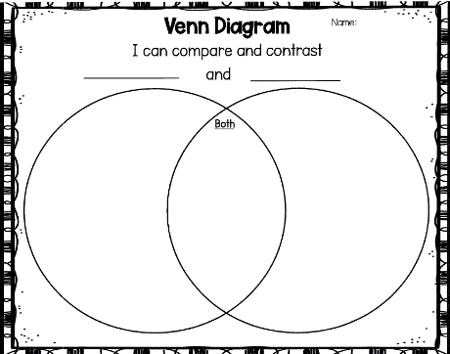
- Use a Venn diagram as a thinking tool to compare, record, and organize how your family prepares for food security and how your grandparents/older person prepared for food security, in the past.

- Create a THEN and NOW picture to show what you learned above.
- Write (or parents can scribe for their child) one or two sentences to explain what you think is the best way to preserve and store food?
- Hand-in your work to your learning consultant
  - Venn diagram
  - THEN and NOW picture
  - One or two sentences to explain what you think
  - Self-reflection Rubric

Grade 3/4
- Have a discussion as a family: How does your family fill your kitchen pantry or freezer for food security?
- Choose a local or global Indigenous group of people to learn about the following:
  - What traditional methods of food preservation technologies did they use?
- Use a Venn diagram as a thinking tool to compare, record, and organize how your family prepares for food security and how Indigenous people preserved food.

- Write 3 or more sentences to summarize similarities or differences that you notice in your Venn diagram.
- Thinking about Food Security, what would you create as a new technology for food preservation for the future?
  - Create a model or diagram/blueprint of your new technology.
  - Write 3 or more sentences to describe how your new technology works.
- Hand-in your work to your learning consultant
  - Venn diagram, and text describing the Venn diagram
  - Model or diagram/blueprint, and text describing the new technology
  - Self-reflection Rubric

Grade 5/6
- Have a discussion as a family: How does your family fill your kitchen pantry or freezer for food security?
- Choose a modern developed country and a modern developing country for this project
Developed Country | Developing Country

  - Look at methods for food preservation technologies. Use a table to organize your findings. Be sure to cite your sources.
  - Collect images that represent your findings. Be sure to cite your sources.
- Write one or two paragraphs comparing food preservation in the two countries you chose.
- Write one paragraph to include what you think are the ethical considerations when we import foods from another country.
- Hand-in your work to your learning consultant
  - Table
  - Images
  - One or two paragraphs comparing food preservation
  - One paragraph about ethical considerations
  - Self-reflection Rubric

Grade 7/8
- Have a discussion as a family: How does your family fill your kitchen pantry or freezer for food security?
- Choose one ancient world for this project (Grade 7 up to the 7th century; Grade 8 from the 7th century to 1750)
  - Look at methods used in your chosen ancient world for food preservation technologies.
  - Make and use a Triple Venn Diagram as a thinking tool to compare, record, and organize the ancient country to its modern equivalent, and modern-day Canada. Be sure to cite your sources.
  - Collect images that represent your findings. Be sure to cite your sources.
- Write 3 to 5 paragraphs to summarize your findings. Include what you think are the ethical considerations when we import food from another country.
- Hand-in your work to your learning consultant
  - Venn diagram
  - Images
  - 3 to 5 paragraphs comparing food preservation
  - Self-reflection Rubric

