Term 2 - Testable Question Project Grades 7-8
- Find a testable question. This can be a question that your child may have about the world around them, especially in your own home or community.

- Try to come up with your own testable question. Please don’t use an experiment from a book or an experiment that you have already tried in the past (no mentos or volcano experiments, please). See the Testable Questions Ideas document for more ideas if you are having trouble coming up with your own.

- Plan Your Experiment
Design an experiment to test your question. Record the plan on the Experiment Planning Form (use our template or make your own). Question: What will happen? State the question the experiment is trying to prove or solve.
  - Hypothesis: What do you predict will happen?
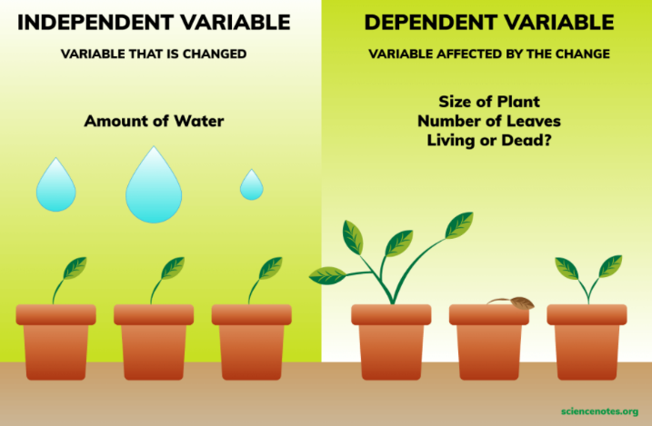
  - Variables: Can you name the independent variable and dependent variables in your experiment? Only one variable should be changed in the experiment. Can you name the variables you need to “control” (keep the same) in the experiment?
  - Experimental Group: What procedure/steps will you take? Number of repeated trials? Trials: repeat the experiment at least once. Is the experiment reproducible? Will another person be able to replicate the results of your experiment?
  - Control Group: What should be kept constant for a fair trial?

- Conduct Your Experiment
  - Carry out the steps to test your question. Record your experiment results on the Recording Sheet (use our template or make your own). Be sure to use a separate Recording Sheet for each trial of your experiment. Trials: repeat the experiment at least once.
  - Observations: What happened in your experiment?
  - Measurement/Data: Organize the data that you are able to measure and observe during the experiment; use tools (such as a ruler, scale, measuring cups, thermometer, timers) for measuring quantitative data. Record results using tallies or a table to collect and record your data as you work through the experiment
  - Picture: sketch/draw or take photos of the results
  - Reflection: Share your results

- Written Summary and Data Organization (graphs or tables)
What are the important things you learned about your predictions? Summarize your results. State if hypothesis was supported or not. What new questions do you have? Suggest improvements to the experiment. If you repeated the experiment, what would you do differently. Did you end up with more than one variable that complicated the results? What would be an area for further exploration?
- Put together all of the components in a way that presents your work. You could make a poster, or a model, or a booklet or any other form that you would like. Include:
  - Experiment form
  - Recording Sheet
  - Written Summary
  - Data Organization
  - Drawings, images, photographs

- The Showcase date is Wednesday February 21st. Students will have the opportunity to share their results and what they found out, with their classmates.

